Literary Analysis Checklist
Before you turn your essay in on Wednesday, make sure you have done the following:
- Formatted your essay according to the MLA guidelines
- Included a Works Cited page
- Proofread your paper (YOU, not just spell check)
- Retrieved the assignment sheet and rubric from your notebook
- Checked your essay against the rubric
- Italicized the title of the novel
- Taken out any uses of first (I, me, we) and second person (you, your)
- Cited all page numbers correctly (Author Page)

Works Cited Page
- Separate page at the end of your essay
- Should have your last name and page number included
- One entry

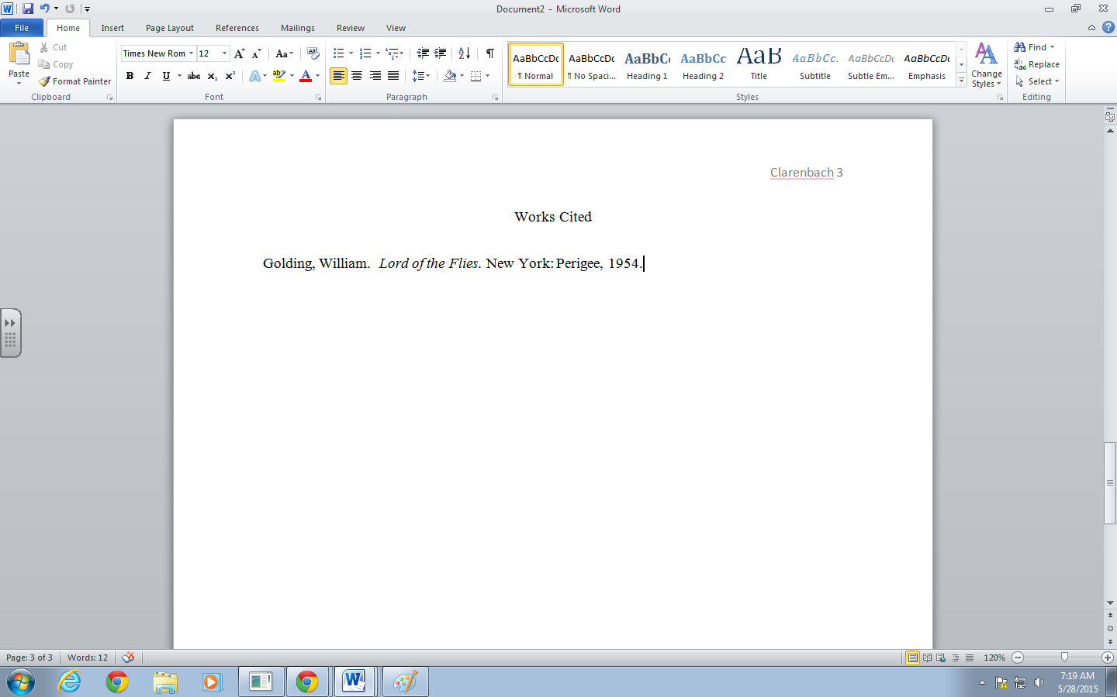

When you turn your essay in, include the following in THIS order:
- Final Draft
- Rubric
- Brainstorming
- Outline/Graphic Organizer
- Draft
- Peer Review

