Paige L. Hanson, University of Michigan-Dearborn

The Renaissance Outfit
"Is that thine codling or art thou glad to see me?" Anne Boleyn, to Duke Fabrizio of Bologna, apocryphal.
Due to laws prohibiting who was allowed to wear what, and the cost of materials, there was a vast difference in attire between the classes. Not only did materials vary, but styles as well, as the lower classes opted for practicality in their clothing by necessity. Lower classes, such as laborers and apprentices would wear linen, a light, cool fabric derived from the flax plant, wool, or sheepskin. Cotton had been in production since antiquity, but its import and manufacture was prohibited in Elizabethan England in order to protect the wool industry, one of England's chief exports. It was not until cotton farming in the new world and Eli Whitney's development of the cotton gin in 1793 that cotton become a favored fabric (Cotton).

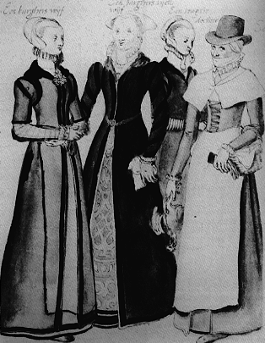
An example of middle-class women's dress, c. 1570

Fabrics available to those in the upper classes included silk, satin, velvet, and brocade. As this was prior to the industrial revolution, all harvesting, weaving, and production of fabrics and clothing was done by hand, thus greatly influencing price. As with fabric choices, the lower classes were limited in the amount of clothing they could afford, and may only have one set of clothing. Liveries, uniforms worn by servants with their master's colors or emblems on them, were provided by the master to the servant. Liveries were exempt from many of the sumptuary restrictions, as they represented the upper class master, not the servant.
While the the materials and sumptuousness of clothing varied greatly between the classes, the basic elements of an outfit were much the same. As with today, styles went in and out of fashion, often rapidly.

Women
The styles of the gowns worn by women in Renaissance England changed from year to year, but the basic styles remained the same. Women wore gowns comprised of a tight-fitting bodice and a fuller skirt that would hang down to the ankles. Dresses cut to expose much of the neckline were acceptable and fashionable. Clothing of the upper classes was heavy and cumbersome, and restricted movement for the wearer. Women of the lower classes wore much less restrictive styles, both for freedom of movement, and because they did not have servants to help them dress. In dressing, a lower class women would wear a much looser corset, or none at all, and would possibly eschew other underpinnings such as bum rolls (crescent-shaped cushions worn around the hips) or farthingales (hoop skirts used to hold the skirts out) for added comfort.

All women's outfits started with a shift (a loose, linen smock worn to protect the gown), and stockings, which were normally knee-high. Petticoats were added both to fill out a gown and to keep the wearer warm.
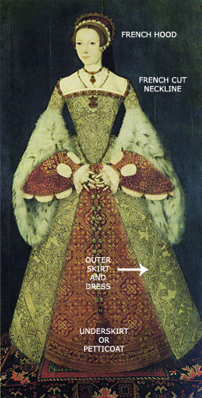

Lady Jane Grey, c. 1545
Men
A man's outfit would start with a shirt, similar to today's dress shirt, but lacking the collar and cuffs we are familiar with, instead sometimes utilizing lace collars and cuffs. Over this would go a doublet, or fitted top, and finally over that a jerkin, a close-fitting jacket. Men of the working class like their female counterparts dressed for utility and might simply wear the shirt alone.
Instead of trousers as we are used to them today, men would wear hose on their legs. The upper hose were (often poufy) knee-length trousers which were met by the nether hose, or stockings, on the lower leg. In the reign of Henry VIII, doublets became shorter, creating a space between the upper hose and the doublet. In order to preserve modesty, the cod piece became popular again, having been around since the middle ages. The cod piece was originally a cloth or animal skin pocket in the from of hose or trouser, but were now made from various materials, and often padded or used for storage - Henry VIII used his codpiece to store money. Once more, these additions to the outfit would be more common in an upper class individual or person at court than the average Englishman (Kosir).
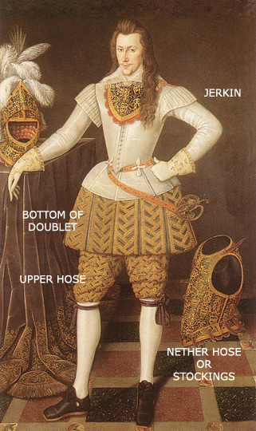
Henry Wriothesley, 3rd Earl of Southhamptam

Children

Children in Renaissance England were considered simply small adults, and their dress reflected this. Children were dressed in clothing very similar to their parents, and both young boys and girls wore dresses during infancy and toddlerhood. For young boys, this aided the mother in toilet training and care giving. When boys were old enough (usually around the age of seven, when they could start helping their fathers) they were "breeched," or put into their first pair of breeches, or hose. This practice continued up until the 19th century in the Western World, and portraiture of young children is often difficult to gender without tell-tale props such as swords or hats.
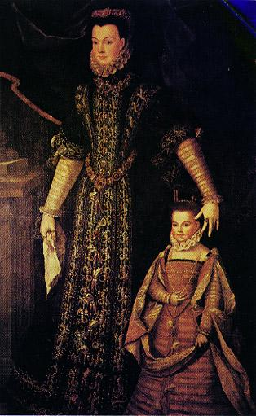
An example of the daughter's clothing mirroring the mother's, c. 1580

The Sumptuary Statues
Which great abuses, tending both to so manifest a decay of the wealth of the realm and to the ruin of a multitude of serviceable young men and gentlemen and of many good families, the Queen's majesty hath of her own princely wisdom so considered as she hath of late with great charged to her council commanded the same to be presently and speedily remedied both in her own court and in all other places of her realm, according to the sundry good laws heretofore provided.
The term sumptuary refers to the sumptuousness, or the excesses clothing. Sumptuary restrictions were not new to the English monarchy or people. Henry VIII's first Parliament met in January 1510 and passed a sumptuary law which took a great deal from earlier acts in 1463 and 1483. The acts passed during the Elizabethan reign build further on her father's act, but share many qualities. Under Henry, colors and cloths were restricted by class, it allowed for the fining of offenders, and also concerned itself not just with men's apparel but women's as well. Henry and his parliament continued to amend and strengthen these laws, focusing on the penalties imposed, further restrictions on fabrics and fabric length, and continuing to allow the King to make special license for those he saw fit (Hooper 433). Elizabeth, upon taking the throne, further stipulated what could be worn and by whom. She first set orders to ensure the earlier acts were followed. A proclamation dated October 21 1559 put the responsibility of ensuring these laws were enforced in the hands of magistrates and men of power. A letter was then sent to the City corporation, urging the passing of this proclamation, and suggesting two watchers per parish be posted to carry out this task (437). Later, again in response to what Elizabeth I termed "the excess of apparel and the superfluity of unnecessary foreign wares" that were believed to cause serious problems for the realm, a series of statues were put into effect, including the largest on June 15, 1574 (Hooper 437). The final statue was the most detailed, and specifically listed fabrics, colors, and designs and very explicitly designated the wearing of them to particular nobles.
All these restrictions, from Henry VIII to Elizabeth I served several purposes, both overt and covert. The most explicit purpose was to address the problem of up and coming young gentlemen and nobles, who in the effort to look their best and wear the best materials available, would spend over their means. This was not only a problem for their families, but the monarchy, as this money could be better spent towards goods that were of better use to the nation. It was also vitally important in a strictly class-based and class-segregated society like Tudor England that people dressed according to the standards of their own class and gender. A class system does not work efficiently if one cannot tell to which class a person belongs, and blurring of class lines takes some of the meaning away from higher positions. This clear distinction between groups is also necessary to curb attempts at upward mobility by the emerging middle class of merchants, and to maintain social conformity and etiquette, which Elizabeth strongly favored. Additionally, these laws curbed the influx of unnecessary foreign goods, in an effort to support English commerce (436).
The punishment for violation of these statutes were fines and/or jail times amounting up to three months for the 1562 statute forbidding any person under the rank of Knighthood wearing silk trimming on hats and other sundries. During Henry's reign, the 1533 Act for Reformation of Excesse in Apparayle had a fine of 3 shillings and 4 pence for every day of the offense (435). This was not an astronomical fine, but it can be imagined it would be a strain on a member of the working classes. Those employing servants who had violated the restrictions could face a large fine as well for not releasing the servant from his employment or hiring him again. Penalties paid were fines, not fees, and person of lower status could not purchase the "rights" to a specific item or material (Secara).
In 1561 restrictions were put on the amount of fabric to be used in hose, and obliged tailors to enter into bonds to observe these provisions. Refusal meant imprisonment and loss of occupation. Searches were made regularly to ensure cooperation, and servants and apprentices were taught also to follow the law (440). On January 24, 1565 Richard Walweyn, a servant whose master had also been brought up on charges for an "outrageous great pair of hose," was detained until he could acquire more appropriate hose for himself. In another instance, merchant tailor Thomas Bradshaw was convicted of wearing unacceptable hose. The court ordered that all the stuffing and linings of one of his said hose shall be cut and pulled out presently, and he to be put in his doublet and hose, and so led home through the street to his Mrs. House, and there the lining and stuffing of the other to be likewise cut and pulled out (441)
Violators of higher office were dealt with more gently. In one instance, offenders described as "gentlemen" were fined £20 and ordered to correct their attire. Even with punishments, the statutes were difficult to enforce. There were appointed officers at court, and alderman were charged to monitor their wards. Elizabeth I set the responsibility of enforcing the restrictions on all clergy for their flock, masters for their servants, neighbors for one another (Secara). However, neighbors were not likely to turn one another in if they wished to violate the statues themselves. By 1566, Elizabeth issued precepts ordering guards at the gates of the city by seven in the morning to:
...having a diligent eye during all the said time to all and every such person & persons as they shall see there to enter into the City of London, or pass or repass at or by the same gate using or wearing any great and monstrous hosen, silk, velvet or weapons restrained and prohibited.
Offenders were taken to the magistrates at the Guildhall (443).
Despite the possible cost in fines to offenders, the best enforcement was public opinion. Public embarrassment was a very effective punishment. Wearing something that did not fit into society's view of the acceptable could be pointed at for ridicule (Secara). Ridicule at court or about town for a violation or inappropriate item would be more damaging, and public, than a fine, as in the case of tailor Thomas Bradshaw, for whom the major punishment was being marched through London to his home in his torn, illegal attire. The mention of his "Mrs." in the above account also implies that violators would also face censure at home.
The specific items restricted were detailed, and covered every aspect of the Elizabethan costume. Among the restrictions listed in Elizabeth I's 1574 statute were:
Purple silk and sable fur: Reserved strictly for the Queen, King, and their family members.
Velvet: The colors crimson and scarlet being reserved for only the highest nobility: dukes, marquises, and earls.
Tinseled cloth: Cloth that was woven with strands of gold and silver, that is, tinsel, was reserved for the nobility including viscounts and barons.
Gold, silver, or pearl embroidery: Reserved for dukes, marquises, earls (including the children of all three), viscounts, barons, and Knights of the Garter.
Lynx and civet cat fur: Restricted to the above ranks, and including the wives of men who can dispend �100 by the year.
Enameled buttons, chains, etc.: Restricted to the above nobility, and including wives of barons' sons, and wives of knights.
Silk, satin, and damask: Reserved for the above, and including knights' daughters.
The statues covered both men and women's clothing. These statues were specific to all ranks of the nobility, and dictated the allowances from the Queen down to knights. The only non-nobles permitted these types of materials and items were those who were in service to the Queen through diplomatic positions, the privy chamber, or other court office, or those men and women in service to nobles, who were permitted materials in their liveries.
There was not only concern in this period for men and women dressing above their status and means, but also, men and women testing gender boundaries by cross dressing. Just as sumptuary violations blurred class lines, so did Renaissance cross dressing blur gender lines. In a strictly gendered and homosocial environment, this was of great concern. The most public instance of cross dressing was in theatre. Women were not allowed onto the stage, and therefore young men and boys would play female roles, dressing completely for the part. This raised concerns about homoeroticism and feminization (Cressy 438). Instances of cross-dressing abound in Renaissance theatre, not only in males dressing for female roles, but female characters dressing as males. That is, a male actor would dress as a female character who in turn dresses as a male. A classic Shakespearean example is As You Like It, wherein the female charatcer Rosalind (played by a male actor) dresses as the male Ganymede.
Off-stage, women would cross-dress for a number of reasons, including to avoid rape, be able to travel alone, practice a profession, or simply to have adventures (Cressy 440). A notable example of female cross-dressing is Mary Firth, also known as Moll Cutpurse, awell-known character about London, who regularly dressed as a man, smoked, and appeared on stage (462). Thomas Middleton and Thomas Dekker's The Roaring Girl is based on Firth. She was forced to appear in court for her transgressions, although was treated lightly (462).
For the most part, off-stage cross dressing was viewed as a prank, or lark and punishments were often mild in the courts (461). Punishments, like for violating sumptuary statutes, were often focused on public embarrassment. One women in 1578 was required to ask her father's forgiveness before communion (460).
Above all, clothing violations, whether classed or gendered were enforced to keep conformity, preserve class distinctions, and with these, preserve social harmony as a gender- and class-segregated society. While the punishments were often light, the number of records of violations and the need of statutes implies the seriousness to which Tudor monarchs viewed the matter.

