MLA Formatting
- Double space
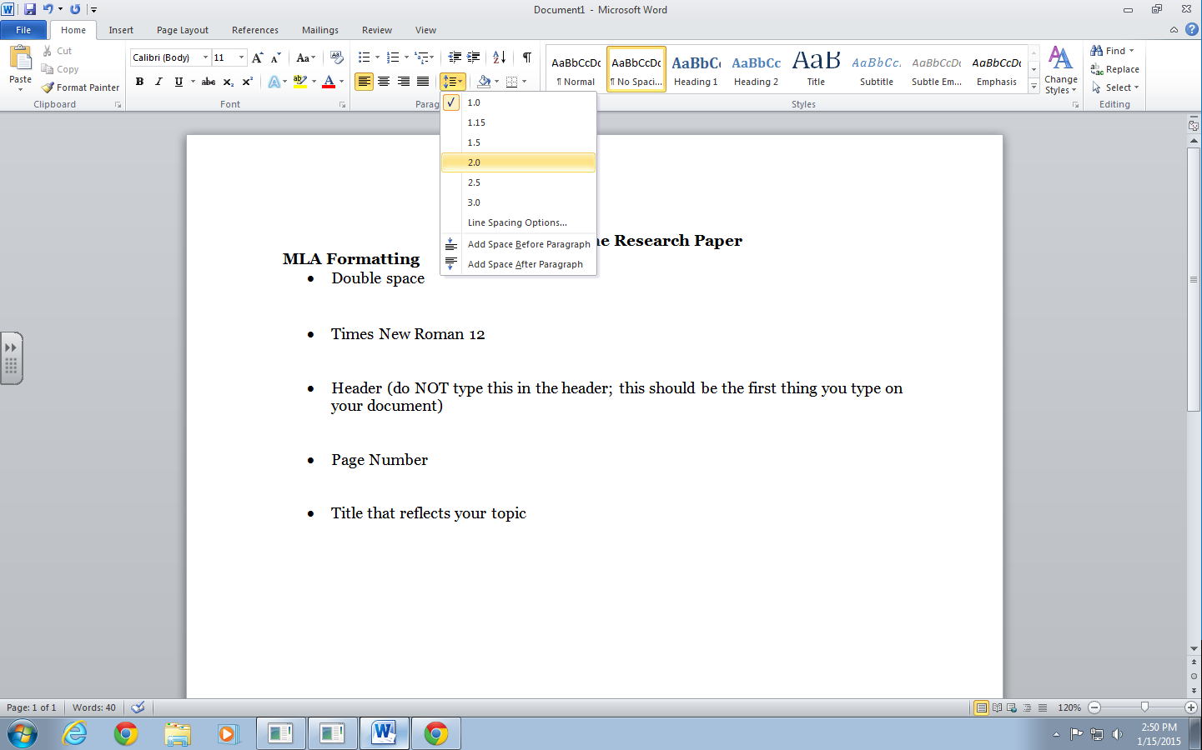

- Times New Roman 12
- Title that reflects your topic
- Header (do NOT type this in the header; this should be the first thing you type on your document)

- Page numbers

